Computer Systems and Internet Technologies - COMP1589

Third Party Technologies
Lab

SUMMARY
In this lab we will look at the use of third party technologies on the web. Many modern websites include a variety of third party technologies such as service providers with SDKs (Software Development Kits) or libraries that we can simply “install” into our code to enhance our site or make things easier for us.

OBJECTIVES
- To understand how to use fonts from third party services
- To understand how to embed rich media services into our sites such as YouTube and Google Maps
- If you get time! To understand how to use third party libraries to quickly add rich content to your website

TASK 1 - Fonts
You may recall from previous weeks where we defined our font for the website, this was using something known as a web safe font (CSS Web Safe Fonts) - one in which we know are distributed well enough across devices to display the same for most users.
We can also use our own custom fonts, there are a few ways to do this (such as having your own font files on the server), however the simplest is by using a service provider to load the fonts for you - let’s give this approach a go.
Step 1
First of all download the HTML5 boilerplate to get started and spend 5-10 minutes digesting the code and files - DOWNLOAD HERE
In particular take a look at the index.html file and then the main.css file.
Step 2
For this task we will be using Google Fonts as our service provider, however there are many other providers out there that you can use.
First of all select what font you want to use, I’d suggest something flamboyant to ensure you can see the difference compared to the default browser font. Maybe Rubik Bubbles or Yeon Sung, have a browse.
Google Fonts Search
Once you’ve picked your font you’ll see a page like below.
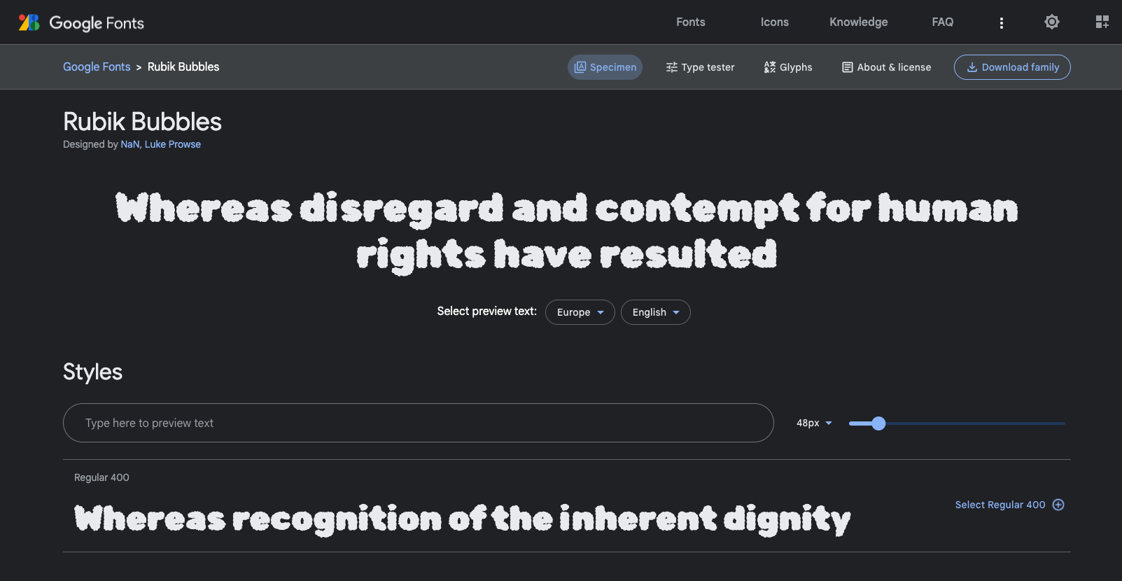
Step 3
Once you’ve picked your font you don’t want to download it, you want to load it in directly from Google.
For that we need to select the family we wish to use, for simplicity let’s just use “regular” (400).
On your selected font, scroll down to where it says “Styles” and find the style called “Regular 400” and click “Select Regular 400” to the right of it.
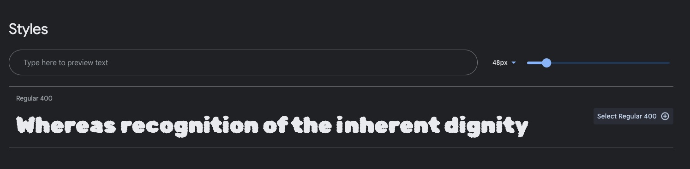
You’ll then see this sidebar open up:
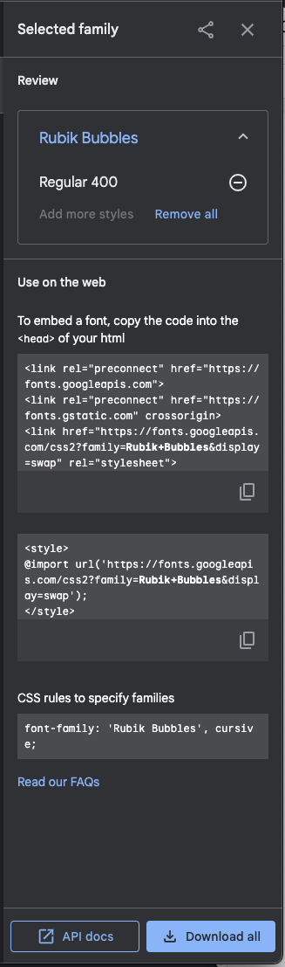
Step 4
First of all let’s copy our embed code, we will use a browser link embed rather than an CSS import for simplicity sake. Click the copy icon on the bottom right.
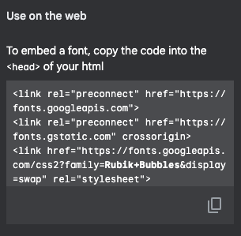
Now let’s add this to our index HTML file, within the head, above the “main.css” link. When formatted it should look like something like this:
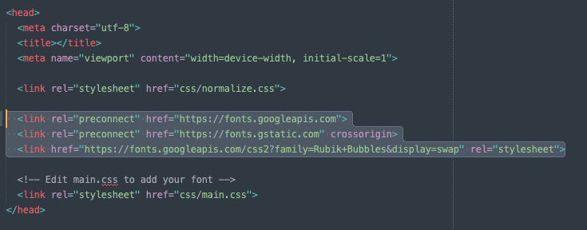
Step 5
We now need to apply our loaded font to our HTML elements, open your main.css file and find the “custom-font” class. In this class you want to add CSS rules from Google.
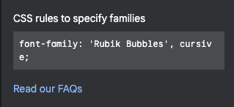
It should look something like this:
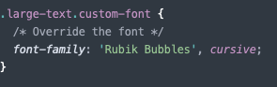
Step 6
If you reload your browser now, or open the index file in your browser if you haven’t already, you should be able to see your new font loaded.
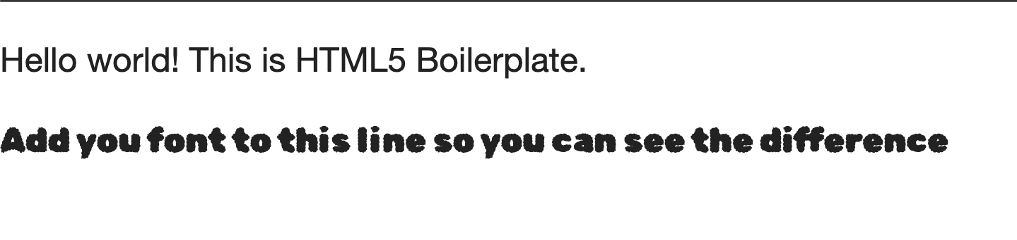
To confirm this inspect the element and you should see the font family applied to the element, overriding the previous font family. Additionally if you reload the page, keeping devtools open, and click “Network” you should see the requests to Google fetching the font.
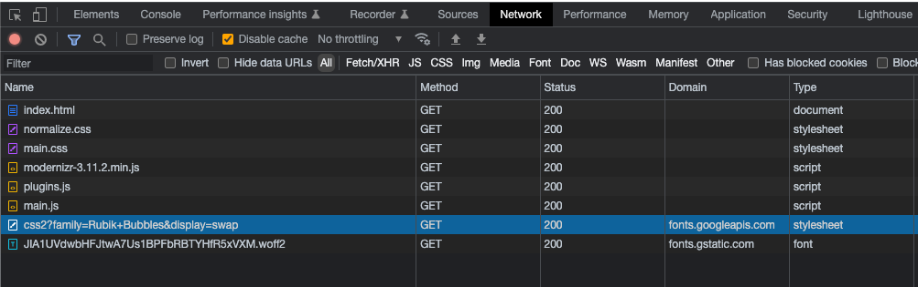
Considerations
You may notice that the text flashes slightly when you load the page, this is due to the time it takes to load the font remotely and then replace the existing font. This is known as a FOUT (Flash Of Unstyled Text - FOUT – Fonts Knowledge).
There is no real easy way to prevent this as all the options are a trade-off but if you want to learn more about this then take a read through the links below.
Using web fonts – Fonts Knowledge - Google Fonts
font-display - CSS: Cascading Style Sheets | MDN

TASK 2 - Embeds
Fonts are just one way to help make a website unique and tailored to your brand, however we also need to ensure that our site is engaging and rich - one way we do this is through the use of embedded content.
This is content loaded in from a 3rd party service, often using a tag known as iFrame (<iframe>: The Inline Frame element - HTML: HyperText Markup Language | MDN) which allows us to load a HTML page inside another page using a window of sorts.
Most services we want to embed are relatively simple, we can often just copy code from that provider and paste it into our HTML.
YouTube
Let’s take a look at embedding a YouTube video within our webpage.
First of all find a YouTube video to embed, to save time you can use this one CES® 2023 Press Conference｜Sony Official.
Within the video click “Share” and embed.
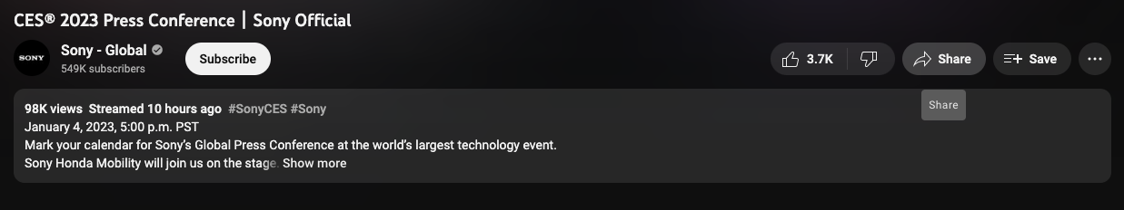
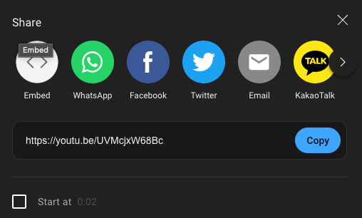
You’ll then be presented with some code and options to configure your embed, majority of the configuration can be done via the URL within the iFrame (the SRC attribute).
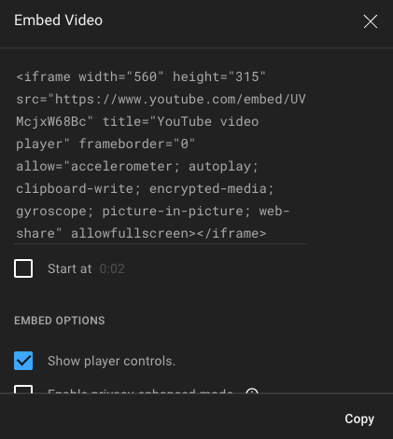
Simply click “Copy” and then paste the embed code into your index HTML file under your P tags.
And there you have it, a simple embed from YouTube.
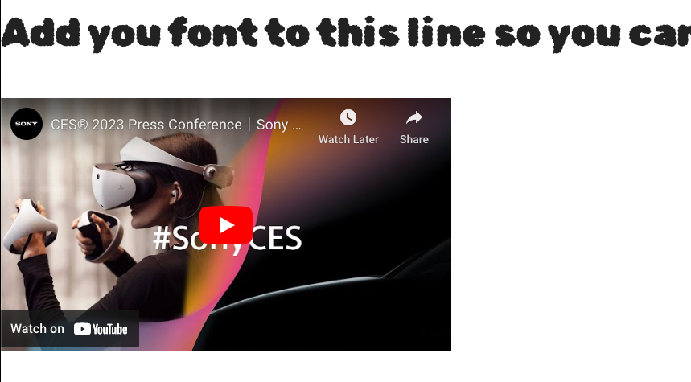
There are more advanced ways to embed from YouTube using JavaScript YouTube Player API Reference for iframe Embeds.
Google Maps
You can do the same with Google Maps, for example navigate to University of Greenwich and see if you can work out how to embed this yourself into your page.
It should look something like this:
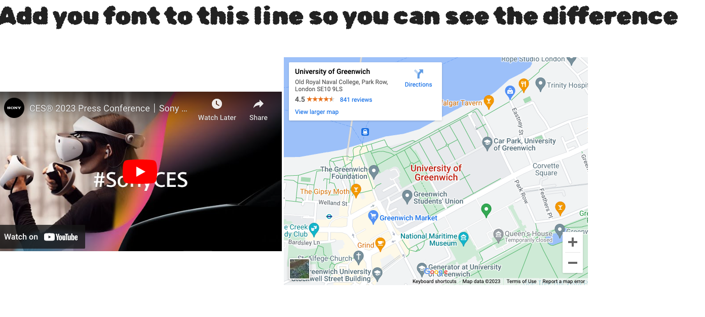

TASK 3 - Libraries
If you get some extra time or want to push yourself then let’s try using third party libraries - for this we will use Chart.js to add some interactive charts to our page (see the links in the Extra section for more info).
Step 1
We need to load the SDK (Software Development Kit) into our HTML file first, at the bottom of our file where we have our script tags. Let's add in the hosted CDN version of the library - copy the below code and paste it above modernizr.
<script src="https://cdn.jsdelivr.net/npm/chart.js"></script>
Now we need add somewhere for our chart to display, so let’s add our placeholder tags into our HTML:
<div>
<canvas id="myChart"></canvas>
</div>
First we need to initialise our graph instance, first of all we must get the element we want to output for use. Make sure you put the correct ID in to get the element.
const ctx = document.getElementById(PUT_THE_ID_HERE);
Then we are going to initialise our chart instance, giving it our output element in the variable “ctx” and our chart configuration object; we set the chart as a bar type here.
new Chart(ctx, {
type: 'bar',
data: {
}
});
Finally let’s add some sample data to see how it looks, within your data object add the following:
labels: ['Red', 'Blue', 'Yellow', 'Green', 'Purple', 'Orange'],
datasets: [{
label: '# of Votes',
data: [12, 19, 3, 5, 2, 3],
}]
You should end up with something looking like this:
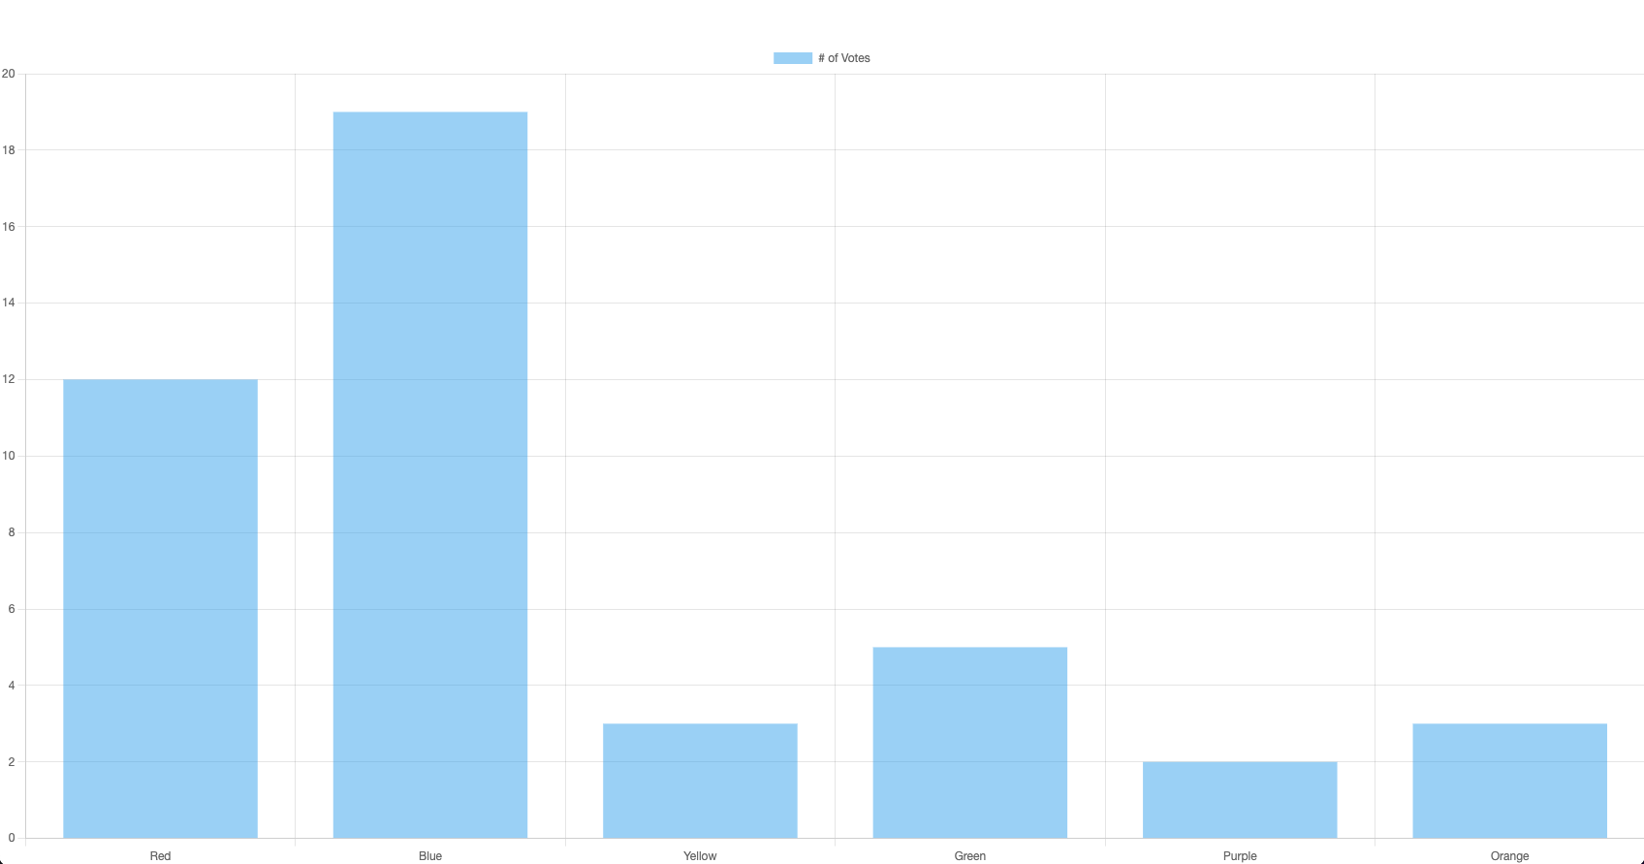
If you have the time, try playing around with the different types of charts https://www.chartjs.org/docs/latest/charts/area.html and other configuration options.

EXTRA
If you’ve completed all the steps above then spend some time experimenting with what libraries you could be using to make development quicker and easier, or see what else you can embed within your page - maybe Twitter or TikTok?
Embeds
Twitter Publish
Embed Videos - TikTok for developers
Embedded Posts - Social Plugins - Documentation - Meta for Developers
What are Embeds on Instagram and how can I embed an Instagram post or profile? | Instagram Help Center
Libraries
Moment.js - Display time in more unique ways such as “5 minutes ago”
Font Awesome - a massive library of icons
Adobe Fonts - Alternative to Google Fonts from Adobe

